NOW IN FULL COLOR!

Dear Parents/Guardians,

Preparations for this school year’s FULL COLOR yearbook are already underway. It is now time for you to begin placing orders to reserve your copy. Pre-ordering your yearbook guarantees that you will not only receive a book that captures all the memories of the school year, but that you get it at the lowest price, too!

The pre-order cost of this year’s yearbook is $17. Because of all the exciting new features, every child will want their own, and yearbooks make great gifts for grandparents, too! So, we are giving a discount to families who would like to order two or more copies at $15 per book. (After the pre-order deadline of February 22, 2013, yearbooks may be purchased for $20 each, or $18 per book for two or more.) We hope you will take advantage of the savings!

Instructions for pre-ordering your yearbook(s) by Friday, February 22, 2013:
- Complete all sections of the order form below and detach at the dotted line.
- Place full payment (cash or check made payable to Columbine PTO) in an envelope with the detached order form.
- Write YEARBOOK on the envelope, seal and return to your child’s teacher or school office.
- Keep the top portion of this page for your records.

Thank you for your order!
CES Yearbook Committee

For Your Records
Student(s): ____________________________________ Date Purchased: ________________
Quantity: _________ Amount Enclosed: _________ Cash Check No. _________

-----------------------------------------------------Cut Here-----------------------------------------------------
2012-2013 CES Yearbook Pre-Order Form
Please complete all fields and print legibly.

Parent: _____________________________________ Phone: _______________________
Quantity: _________ Amount Enclosed: _________ Cash Check No. _________

The information below will help us ensure proper yearbook delivery to students. If ordering two or more yearbooks for the same student, please also indicate the quantity.

Student: ____________________________ Teacher/Grade: ________________ Qty. _____
Student: ____________________________ Teacher/Grade: ________________ Qty. _____
Student: ____________________________ Teacher/Grade: ________________ Qty. _____
Want to share your candid photos of CES events and activities? We would love to have them! And with eShare, it’s so easy to do! Just follow these instructions:

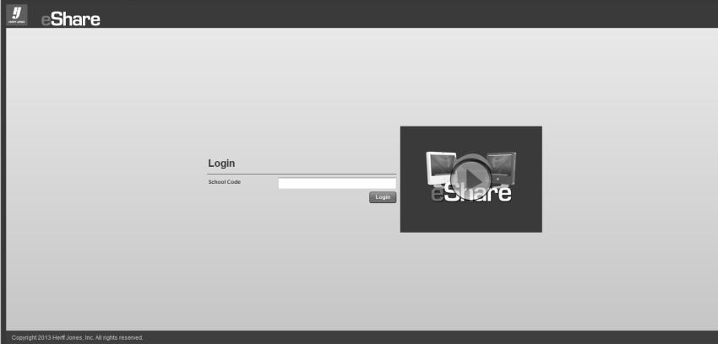
Step 1: Go to www.hjeshare.com
and enter our school code:
CESYEARBOOK
CESYEARBOOK.

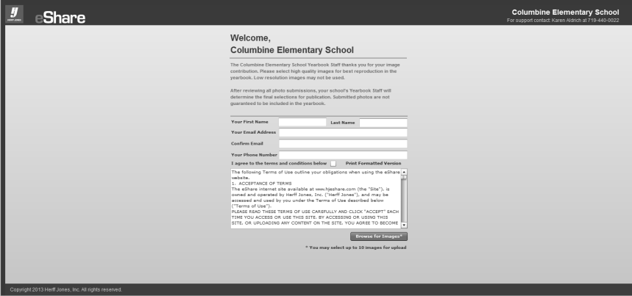
Step 2: Read the welcome and
photo submission selection
information, complete the
required fields and click
Make sure to read the terms and conditions and check the box that you agree to them!
“Browse for Images.” Then, click
“OK” on the following image
upload screen.

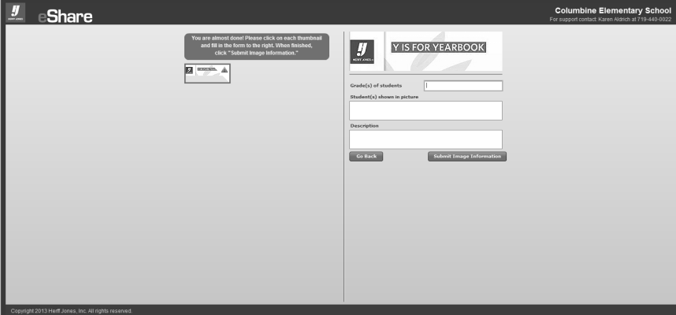
Step 3: Complete the fields
regarding photo information
making sure to spell names
correctly. Then, just click
“Submit Image Information.”

Also, check out the eShare app for
iPhone and Android. It’s a great way
to share photos from mobile phones.

